

**Data management and Database Design (INFO 6210)**

**Views and Visualization**

**Team - 20**

**Team Members**

Ashwin Muthiah Murugappan ([murugappan.a@husky.neu.edu](mailto:murugappan.a@husky.neu.edu))

Vijayalakshmi Siddappa ([siddappa.v@husky.neu.edu](mailto:siddappa.v@husky.neu.edu))

Naga Mahesh Tiruveedhula ([tiruveedhula.n@husky.neu.edu](mailto:tiruveedhula.n@husky.neu.edu))

**Visualizations**

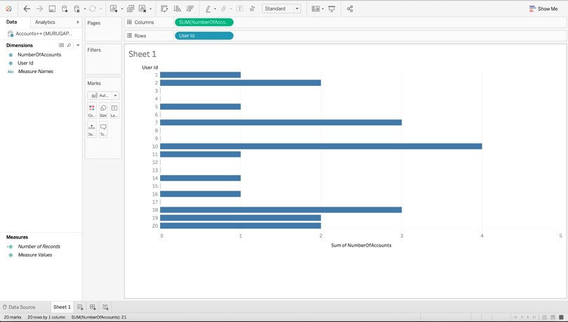

**Figure 1** - Report shows number of accounts each user has in the Database. Sum of Number of Accounts is on the X-axis User id is on the Y- Axis 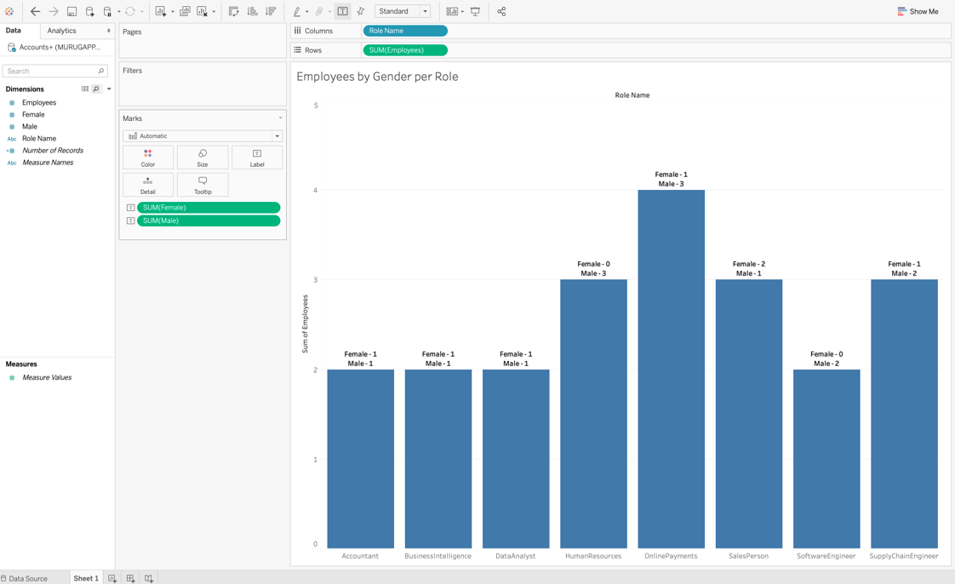

**Figure 2** - Report primarily shows number of employees for each role. Role Name on the x-axis Sum of Employees on the Y-axis. Additionally, we can also get the count of male and female employees in each role.

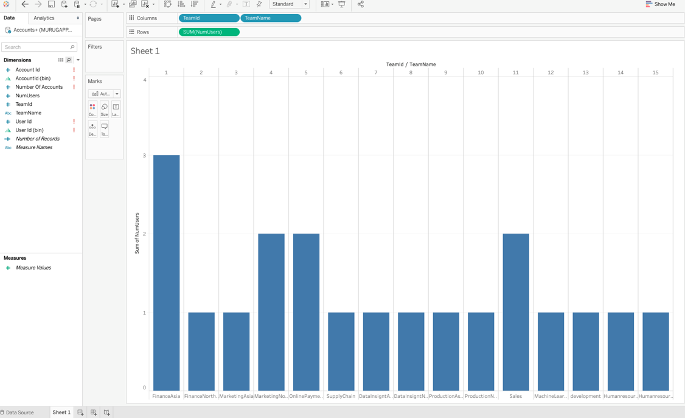

**Figure 3** - Report shows number of users/employees each team has. Team Id/Team Name on the x-axis. Sum of Number of Users on the Y-Axis.

**Views**

**V_ActiveAccountsWithOutAnyPermission**

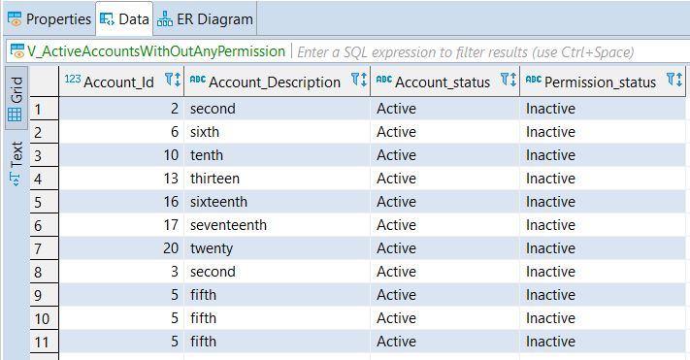

**V_GenderRatioByRole** 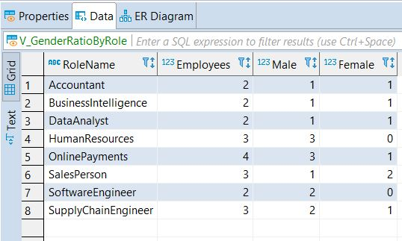

**V_NumAccountsPerUser** 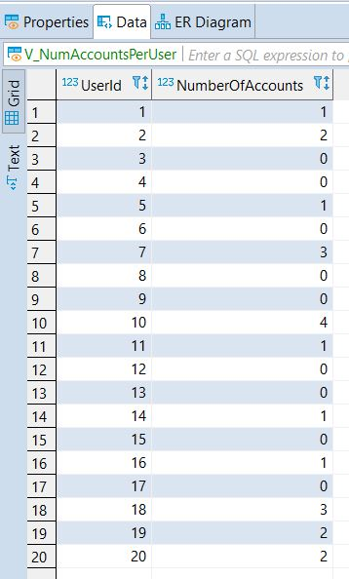

**V_UserAccountPermissions** 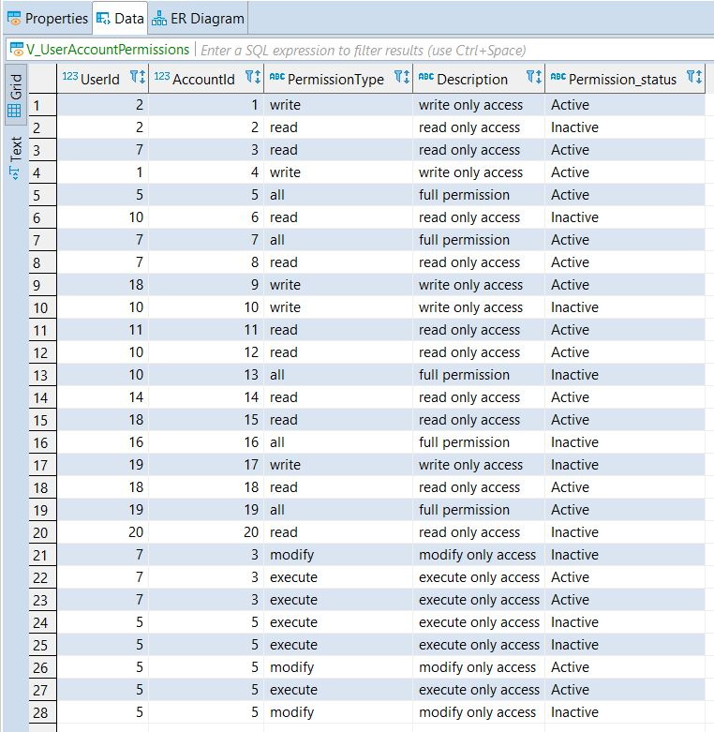 **V_UserTeamDetails** 